Whole Class Readers
 | Class 2 |  | Class 3 |  | Class 4
Book 1 | 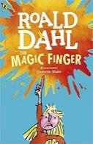 | R. Dahl  The Magic Finger | 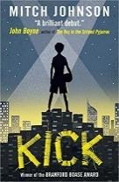 | Kick  M Johnson | 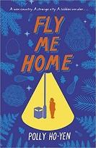 | Fly me home  P Ho-Yen
Book 2 | 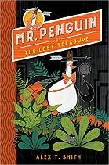 | Mr Pengiun – Lost Treasure  Alex T Smith | 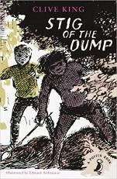 | Stig of the dump  C King | 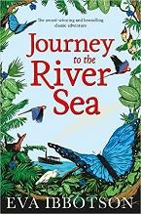 | Journey to the river sea  E Ibbotson
Book 3 | 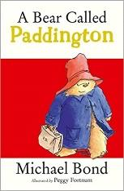 | M Bond  Paddington | 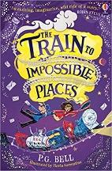 | Train to impossible places  P G Bell | 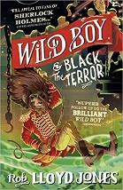 | Wild Boy  J Lloyd
Book  4 | 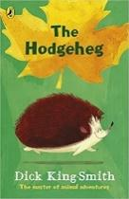 | D King Smith  The Hodgeheg | 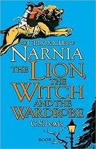 | The lion, the witch and the wardrobe  C S Lewis | 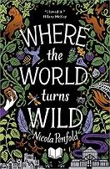 | Where the world turns Wild  N Penfold
Book  5 | 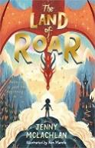 | The land of roar  J Mc Lachlan | 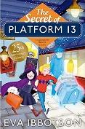 | Platform 13  E Ibbotson | 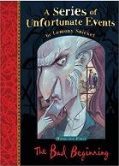 | Bad beginnings  D Handler
Book  6 | 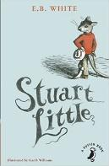 | Stuart Little  E B White | 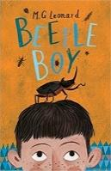 | Beetle Boy  M G Leonard | 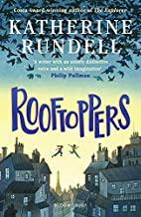 | Rooftoppers  K Rundell

- These books to be used for daily whole class reading sessions, using the Literacy Shed Plus teaching notes to inform sessions and concentrating on building vocabulary and developing comprehension skills.
- They are designed to be read as one book per term. If you read a different text to your partner class in the other school, then most classes should be able to have one book per child, which makes the sessions the most effective. Please liaise over this. The books can be read in any order throughout the year but please make sure that they are all read over the 2 year mixed class cycle.
- They are mainly in sets of 28. They are kept in Parker’s library. Please make sure all books are returned to Parker’s library after use so we keep full sets.
Should you finish the book before the end of term, we also have the following stock of readers at Parkers that can also be used for whole class reading . Many have planning units on Literacy Shed Plus.
KS1
Pumpkin soup
Woolfe
Flat Stanley
Toby and the great fire

LKS2
How to train your dragon
Toms midnight garden
The firework makers daughter
The Stone Age boy

UKS2
Treasure island
Alice in wonderland
War horse
Private peaceful
The secret garden

