Dear Parents/Carers

OPAL play has been very successful so far. The children are loving all of the new toys and equipment that is outside at lunchtime. In order to continue to develop this provision and to make it even better we need yours and the local communities help. We are on the lookout for lots of pre-loved or excess toys/equipment to add to our OPAL offer. Below is an OPAL play bingo card. Each class is competing to finish the game of bingo. If you have any of the resources listed on the bingo cards that you are able to donate we would be incredibly grateful. Please send the items in to school with your child. The class who finish their game of bingo first will win a prize.

Thank you for your continued support!
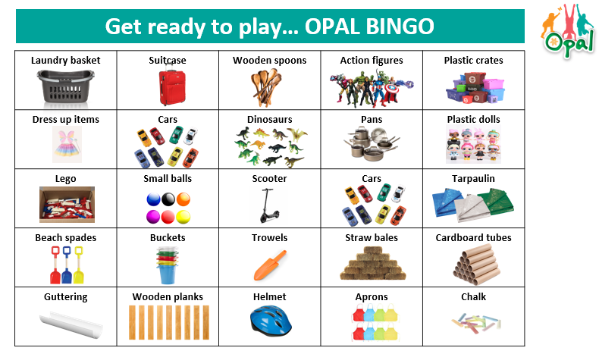
Mrs Disney



