18th September 2025

Dear Parents/Carers

The school has purchased Maths and English SATS revision books for our Year 6 students to use in school.
If you wish to order additional books for your child/ren to use at home please complete the form below. These books will be ordered at a discounted price through the school.

Please return all forms to the office by Monday 29th September 2025. Once we have all order forms payments will be added on to Parent Mail. Books will be in school ASAP.

Mrs Sarah Disney

Executive Head Teacher
Parker’s C of E Primary Academy

Book | Price | Quantity  e.g 1
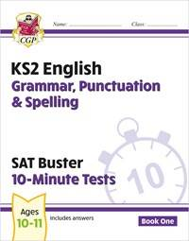  KS2 English SAT Buster 10-Minute Tests: Grammar, Punctuation & Spelling - Book 1 (for 2026) | £2.60
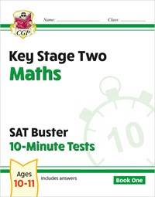  KS2 Maths SAT Buster 10-Minute Tests - Book 1 (for the 2026 tests) | £2.60
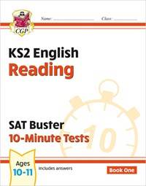  KS2 English SAT Buster 10-Minute Tests: Reading - Book 1 (for the 2026 tests) | £2.60
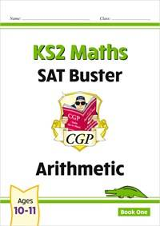  KS2 Maths SAT Buster: Arithmetic - Book 1 (for the 2026 tests) | £2.15
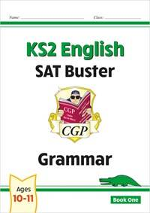  KS2 English SAT Buster: Grammar - Book 1 (for the 2026 tests) | £2.15
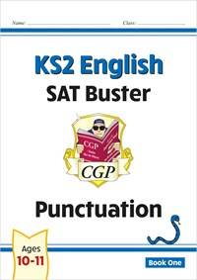  KS2 English SAT Buster: Punctuation - Book 1 (for the 2026 tests) | £2.15

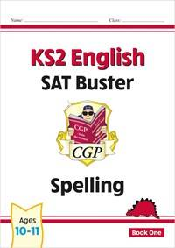  KS2 English SAT Buster: Spelling - Book 1 (for the 2026 tests) | £2.15
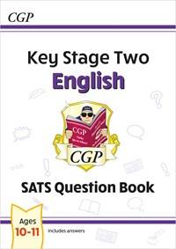  KS2 English Year 6 SATS Question Book (for the 2026 tests) | £2.85
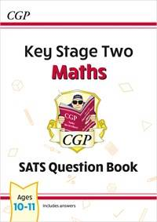  KS2 Maths Year 6 SATS Question Book (for the 2026 tests) | £2.85
Total | £

