Welcome to Parker’s VC Primary Academy.


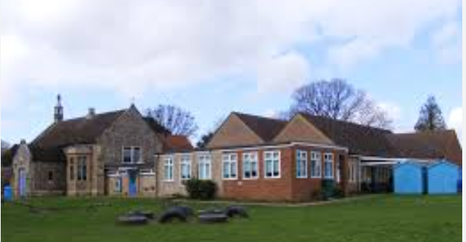

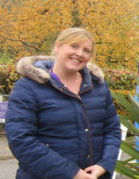
A warm welcome from the Executive Head teacher
Mrs Disney.
Dear Parents and Carers,
Thank you for considering Parker’s Church of England (VC) Primary School for your child. Since joining the Diocese of Norwich Education and Academies Trust (DNEAT) on November 1st, 2020, we have continued to offer a supportive, Christian environment for our students, guided by our school vision inspired by Matthew 7:7 – “Ask and it will be given to you; seek and you will find; knock and the door will be opened to you.”
We are proud of our recent Ofsted rating of Good (September 2023), which reflects the hard work and dedication of our staff, students, and community. At Parker’s, we live by our core values: Respect, Kindness, Responsibility, Hope, Strength, and Unity. These values are at the heart of everything we do, shaping the way we interact with each other and approach learning.
We are more than happy to welcome you for a visit to our school if you'd like to see it for yourself. If you have any questions or need more information, please feel free to get in touch.
Starting school is the beginning of a partnership between Parents/Carers, the School, and the Pupils, and we are excited to work together to help your child grow into a thoughtful, caring individual. We aim to create an inclusive environment where every child is supported in their unique learning journey.
You’ll find more information in this prospectus and on our website, but don’t hesitate to contact me if you need anything else.
We look forward to welcoming you and your child to our school!
Warm regards,
Mrs. Sarah Disney

This version incorporates the key aspects of your school vision, Ofsted rating, and core values, while maintaining a friendly and welcoming tone.

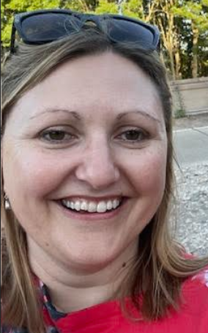
Growing together at Parkers Primary: – A friendly welcome from
Mrs Lansdell
Welcome to Parkers Primary Academy!
My name is Mrs. Lansdell, and I am both the Head of School and the teacher for our wonderful EYFS class here at Parkers. I want to personally extend a warm welcome to you and your family as part of our school community. I am always here for you and your child, whether it’s to chat about day-to-day life or to discuss anything you need. While Mrs. Disney, our Executive Head, works across both of our federation schools, I am here on the ground, ready to listen and support. You’ll always find me approachable, and I truly believe in keeping an open door for communication.
At Parkers, we want every child to have the best possible experience during their time with us. Each child is on their own unique learning journey, and we are committed to helping them grow, explore, and flourish. Our vision is inspired by Matthew 7:7, which reminds us, “Ask and it will be given to you; seek and you will find; knock and the door will be opened to you.” We want to create an environment where every child feels they can ask, seek, and grow, knowing they are supported every step of the way.
Our school values are at the heart of everything we do—respect, kindness, responsibility, hope, strength, and perseverance. We live by these values each day, encouraging every child to not only grow academically, but also to develop into kind, thoughtful, and responsible individuals.
As a Safeguarding Lead, your child's safety and well-being are my top priority, and I am here to ensure they are always supported in a safe, caring environment.
I look forward to working closely with you and your child to create a nurturing space where every child can thrive. Please don’t hesitate to come and see me if you need anything at all—I’m here to listen and help.
Warm regards,
Mrs. Lansdell
Head of School

Contact Details


Address: Parker’s Church of England Primary Academy
Pound Hill, Saham Toney, Thetford
Norfolk, IP25 7HP
Telephone: 01953 881601
School website: www.parkers.norfolk.sch.uk
School email: office@parkers.dneat.org
Chair of Governors email: office@parkers.dneat.org
Chair of Governors: Mr Bruce Gordan
Executive Headteacher: Mrs Sarah Disney
Head of School: Mrs Carla Lansdell
Federation Support Manager: Mrs Helen Jeffries
School Secretary: Mrs Debbie Tumath
Chair of Friends of School: Miss Sarah Pattison

School Closure Information
While the school rarely closes due to bad weather, in the event of severe conditions, please check for closure updates using the following sources:
Local radio: BBC Radio Norfolk 95.1FM & 104.4FM
Norfolk County Council's website: www.schoolclosures.norfolk.gov.uk
The school’s website: www.parkers.norfolk.sch.uk

The Staff Team
Executive Head Teacher: Mrs Disney  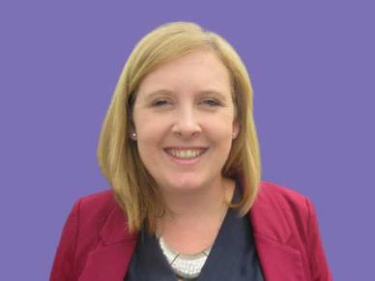 |  | Head of School/EYFS Teacher: Mrs Lansdell  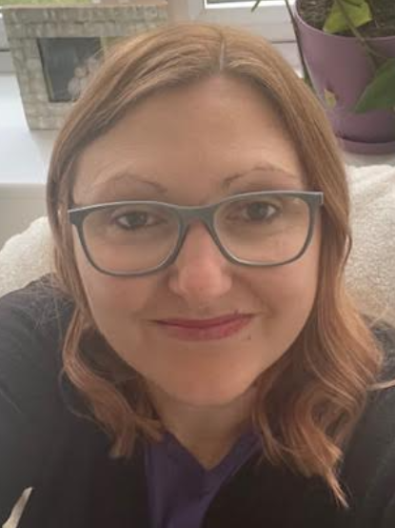
Butterfly Teacher: Mrs Walls   |  |   Firefly Teacher: Miss Vansittart
Dragonfly Teacher: Mr Davis   | School Clerical Assistant: Mrs Tumath  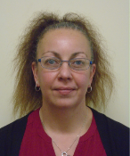
Federation Business Manager: Mrs Jeffries  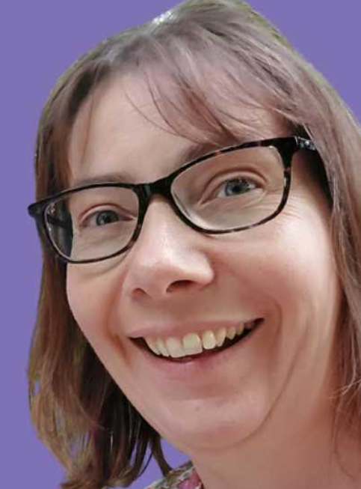 | Federation SENCO: Mr Halmshaw (based at Caston Primary Academy)  

Teaching Assistants and Support Staff
Mrs Woods | Miss Slessor | Miss Head | Mrs Davis
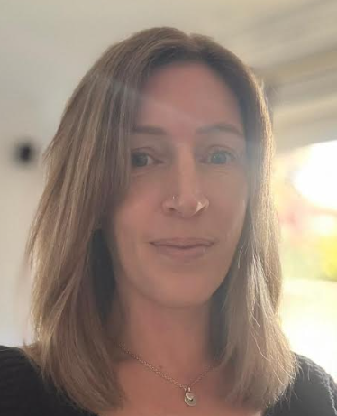 |  | 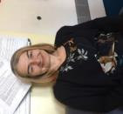 | 
Mrs Colley (QTS) | Mrs Neale (QTS) | Miss Cavanagh (HLTA) | Mr Roast (Caretaker)
 |  |  | 

Midday Supervisors
Mrs Deacon | Miss Saville | Mrs Swann
 |  | 

Breakfast Club Leader | After School Club leads
Miss Saville | Mrs Deacon | Mrs Cook
 |  | 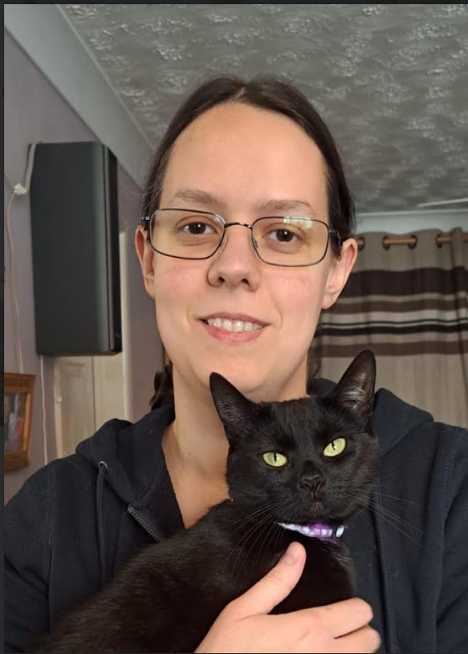

School Uniform

Uniform available from Birds of Dereham - www.birdsofdereham.com

Navy blue sweatshirt or cardigan with school logo. | 
Red sweatshirt (Ladybirds – Pre-school only) | 
White polo shirt | 
Grey or white socks or tights | 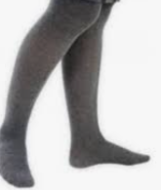
Blue and white checked dress (Summer weather) | 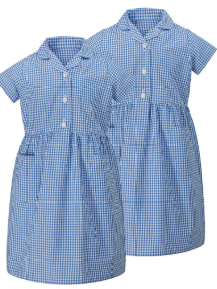
Black school shoes | 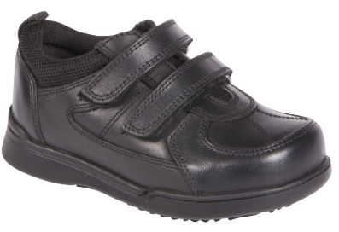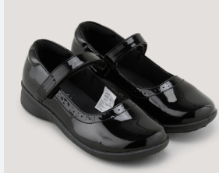
Wellington Boots (to allow children to go out in all weathers to be kept in a plastic bag) – any style/colour to remain in school. | 
PE Kit

T-shirt in house colour  When your child starts school, the office will inform you of the team or class your child has been assigned to. | 
PE Shorts | 
Trainers (any colour and style – different to school wear) | 
Indoor shoes should be different to those worn outside or children should go be in bare feet – plimsols can be worn but not essential. | During winter months and cold weather tracksuits can also be worn.
A typical School Day

The school gates open at 08:45, and the school day officially begins at 08:50.
- First session: 08:50 – 09:15
- Second session: 09:15 – 10:15
- Break time: 10:15 – 10:25
- Third session: 10:30 – 10:45
- Fourth session: 10:45 – 12:00 (This session may include various learning activities.)
- Lunch break: 12:00 – 13:00
- Afternoon sessions: 13:00 – 15:00
- Collective Worship in the Hall: 15:05 – 15:20
- End of the school day: 15:20
This structure ensures a well-balanced day with a mix of focused learning, break times, and opportunities for reflection and worship.




Welcome to Parkers Primary School!
At Parkers, we believe in creating a welcoming, supportive, and inspiring environment where every child is encouraged to grow and thrive. As a parent, you are an essential part of our school community, and we are always excited to welcome you in to share in the joys of your child’s learning journey.

Throughout the school year, we invite you to attend a variety of exciting events to connect with your child's learning. Termly parent events in your child’s class offer a great opportunity to see first-hand what they are working on. Additionally, we hold weekly Celebration Worships, where parents can join us to celebrate their child’s achievements and hard work, including receiving certificates for demonstrating our school values. We also have a fun Reading Incentive programme, where children can win prizes and book vouchers for their reading efforts – what better way to motivate your child to explore the joy of books!
Get Involved – Parent Events and Celebrations

Parents evening and communication.
To keep you informed of your child's progress, we hold Parent Evenings twice a year in the Autumn and Spring terms. This is your chance to sit down with your child’s teacher and discuss how they are doing in school. We understand the importance of keeping you informed and ensure that communication is always clear and accessible. We regularly send newsletters and letters via email, text, and our website, and you can also collect paper copies at the school reception. Please keep your contact details updated so that you never miss an important update!
We know that busy families need flexibility, which is why we offer a Breakfast Club and Wrap-Around Club every day. Your child can enjoy a healthy breakfast, followed by fun activities, or take part in our Wrap-Around Club for after-school care and dinner. These clubs provide peace of mind for parents while offering children a chance to unwind and engage in enriching activities outside of the classroom
Breakfast Club &
Wrap-Around Care
At Parkers, we offer healthy, delicious lunches cooked on-site by Nourish Catering. Children have a variety of nutritious choices to enjoy, with meals ordered easily through our parent portal. To broaden your child’s learning experience, we also provide fantastic school trips. We encourage parents to volunteer as helpers on these trips – it’s a wonderful way to get involved and see your child’s education come to life. If you're interested in volunteering, please contact Mrs. Disney or Mrs. Tumath, and we'll guide you through the DBS process.
Nutritious Meals & Learning Opportunities

Homework and Learning Support
Each week, your child will receive homework planned by their class teacher to reinforce what they are learning in school. We also send home a half-termly newsletter to keep you informed about the topics and projects your child will be working on. If you ever have any questions about homework or how to support your child's learning at home, don't hesitate to reach out.

Supporting Children with Special Educational Needs

At Parkers Primary School, we are committed to providing the best possible learning experience for every child, including those with special educational needs. We understand that each child is unique, and we work closely with families to ensure that we meet their individual needs and help them thrive.
If your child has special educational needs, we work in partnership with you, alongside our SENDCO, Mr. Halmshaw, and your child’s class teacher, to ensure that the right support is in place. We are dedicated to creating a tailored approach for your child, using a range of strategies and resources to support their learning and development.
If your child has, or is in the process of receiving, an EHCP (Education, Health and Care Plan), please make sure to inform the school office so we can ensure the appropriate provisions are put in place.
We are proud to have a supportive environment where regular meetings are held with children on our SEND register to monitor their progress and make any necessary adjustments to their support. Our goal is always to provide the best possible outcomes for all children, and we are here to help your child make the best progress they can.
At Parkers, we are dedicated to supporting every child’s journey, ensuring they feel valued, understood, and empowered to succeed.
Join the Friends of the School

We have a dedicated and passionate Friends of the School group, run by Miss Pattison. They work hard to raise extra funding to enhance our school and offer exciting opportunities for our children. If you’d like to get involved and make a difference, please contact Miss Pattison or stop by the office to find out how you can contribute.

Toddler Group – A Warm Welcome for Families

At Parkers, we are also here for the youngest members of our community! We run a weekly toddler session for children aged 4 and under, providing a relaxed space for little ones to play, explore, and enjoy activities with other toddlers. The session is also a wonderful opportunity for parents and caregivers to socialise, with free tea and coffee available to enjoy while you chat with others. This group is open to everyone, whether or not your child currently attends Parkers Primary, so feel free to bring your friends along and spread the word!

We pride ourselves on clear, consistent communication. Our website, www.parkers.norfolk.sch.uk, is regularly updated with important dates and information about our curriculum, events, and school policies. We also encourage you to check our text messages and emails for the latest news. If you prefer paper copies of letters, just let the office know, and we’ll ensure you're kept in the loop.
Staying in Touch.
At Parkers Primary School, we are dedicated to providing a caring, engaging, and enriching environment for your child. We look forward to partnering with you as we inspire your child to achieve their best and grow into confident, compassionate individuals.
We can’t wait to welcome you and your child to Parkers!

Teaching and Learning
Our Curriculum

Our curriculum is literacy based and linked to topics that lend themselves to a particular genre. We aim to inspire the children with our school values of Respect, Kindness, Responsibility, Hope, Strength & Unity
School Ethos

- To give each child experience of a wide programme of study including the requirements of the National Curriculum
- To make provision for all pupils to develop their academic, moral, social and cultural potential.
- To foster an attitude of care and respect for others through the religious and moral education and through the general ethos of the federation.
- To develop skills appropriate to the individual child’s capabilities.
- To stimulate and develop the child’s interests and capabilities.
- To encourage care and respect of the environment and the local community, alongside an awareness of the wider community in which we live.
- To provide equality of opportunity and equality of regard for every member of the federation community.
- To enable pupils to learn a wider range of skills
Aims of our Curriculum

Through our curriculum teaching, we have the following aims for our pupils:
- To provide challenge, enjoyment, personalisation and progression.
- To provide children with the skills they need to succeed.
- To be able to reflect and evaluate.
- To develop pupils’ independence so that they are able to apply their learning independently.
- To develop a secure subject knowledge which they are able to apply and retain.
- To develop and broaden pupils understanding of language and vocabulary and be able to apply this to everyday conversations and learning.
- To encourage pupils to take pride in all that they do.
Knowledge Rich Curriculum (Knowledge Led)

At the Dove Federation we have designed a curriculum which focuses on the knowledge we wish to teach our children. Our aim is to ensure that the knowledge which is taught is in-depth, can be recalled and applied within learning. Language acquisition is a key focus, we wish to develop and enhance pupils understanding and use of language through the curriculum.

Wherever possible we try to ensure that the knowledge that we teach is influenced by the pupil’s interests. All of our learning is led by the National Curriculum and we use progression maps to ensure that the National Curriculum is being effectively covered.
How we deliver our curriculum

At the Dove Federation, each National Curriculum subject is timetabled into a weekly timetable to ensure that there is adequate coverage. In order to further enhance and allow for further opportunities for curriculum coverage we try to plan curriculum theme days for religious education, humanities, science and the arts. We also try to plan engaging school trips, which enhance the curriculum we are teaching.
How we teach

We try to use a variety of different ways to teach across the curriculum to ensure that all learning styles are catered for. As it, usually takes at least 3 times of hearing, seeing and doing something for a new skill and knowledge to be retained we try and re-visit previous learning as often as possible. Whenever possible we try to make lessons practical, investigative and active and try to create a good balance between this style of teaching and written work. This means that not all learning is recorded in books. We try to keep evidence of the practical work that we do through creating displays of our work and putting photographs of our practical work in a whole class floor book.

At Parkers Primary, we believe in nurturing every child’s potential and providing a well-rounded education that goes beyond academics. Guided by our school vision, inspired by Matthew 7:7 – "Ask and it will be given to you; seek and you will find; knock and the door will be opened to you" – we are committed to offering our pupils a curriculum that fosters curiosity, growth, and a sense of purpose.

More Information for Parents
  Sickness or absence | If your child is unwell and unable to attend school, please inform us before registration. As part of our cluster policy, Mrs. Tumath will ask for the reason for the absence. If you're unsure whether your child should attend school, we have a leaflet available at the office to guide you. Often, children feel better once they are in school, so please try to bring them in if possible. If your child is unwell for more than one day, please contact the school each morning before 9:00am. This is important for safeguarding purposes.
  Holidays | We encourage good attendance, with a target of 97% or higher, as it plays a key role in your child's success at school. Holidays taken during term time will not be authorised, unless in exceptional circumstances.
  Medicine | If your child requires medication during the school day, you will need to complete a medication form available from the office. This form should include details of the medication, the dosage, and the times it should be given. Please ensure the form is submitted to the office for our records.
  Injury or Illness | If your child is injured or becomes unwell during the school day, we will provide first aid and, if necessary, contact you. If we are unable to reach you, we will contact a health professional for advice. Please ensure your contact details are up to date, including your address and phone number.
  Swimming | Pupils in Years 3, 4, and 5 participate in weekly swimming lessons every Thursday afternoon during the Autumn and Spring terms at Thetford Leisure Centre. Swimming instructors are on hand, and pupils are accompanied by school staff and parent volunteers.
  Valuables and Jewellery | Please ensure that valuables are not brought to school, as we cannot accept liability for any loss or damage. The only jewellery permitted are watches and small stud earrings. Earrings must be removed for PE, games, and swimming. The taping over of earrings is only allowed in the initial weeks after ear piercings, except for swimming, where earrings must be removed. We recommend piercing ears at the beginning of the summer holidays to avoid any issues during school activities.
 | We understand that complaints can sometimes arise, and we take them seriously. If you have a concern, please first speak with your child’s teacher. If the issue remains unresolved, you can escalate it to the Head of School or the Executive Head Teacher. Should the matter still not be resolved, please ask for the Complaints Procedure.

We look forward to welcoming your child to Parkers Primary Academy, where we are dedicated to nurturing their growth and success. Our doors are always open, and should you have any questions or queries, please don’t hesitate to reach out. As we live by the words of Matthew 7:7, 'Ask and it will be given to you,' we are here to support you every step of the way.

