Welcome to EYFS at Parkers C of E Primary Academy
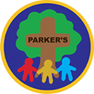
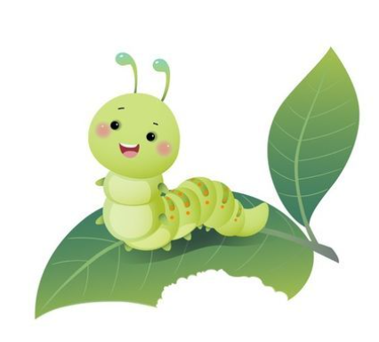


Caterpillar and Ladybird Class.
For 3-5 Year olds
Preschool and Reception.

Welcome to Our School!
Hello, little friends and families! We are so excited to have you here with us at Parkers Primary Academy. This is a special place where every day is full of fun, laughter, and learning. Here, we believe in the power of asking, seeking, and knocking—just like the Bible verse Matthew 7:7 says: “Ask, and it will be given to you; seek, and you will find; knock, and the door will be opened to you.”
This means that at our school, we love to explore, discover, and ask lots of questions together. Whether we are reading a story, singing a song, playing with our friends, or creating something new, we are always ready to ask about the world around us, seek new things to learn, and knock on the doors of curiosity to see what amazing adventures await us!
Our teachers are here to help you grow, learn, and become the wonderful little people you are meant to be. We can’t wait to see you smile, share your ideas, and make new friends!


Welcome to our school! Let's have an amazing time learning together!

Mrs Disney (Executive Headteacher)

Mrs Lansdell (EYFS lead/Head of school)

Mrs Colley Mrs Davis

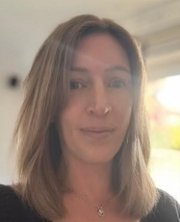

Ms Cavanagh Mrs Woods

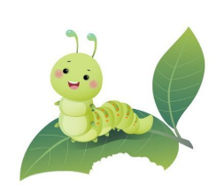

Pictures
Take a look at some of the wonderful photos of our school! These snapshots give you a glimpse into the happy, busy days we have here, from our colourful classrooms to the fun outdoor play areas. We hope these pictures help you feel even more excited about being part of our school family!

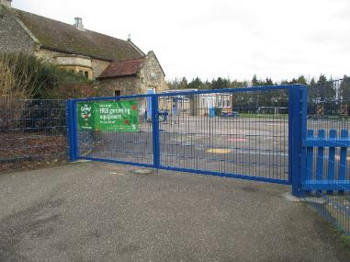 |  | Here’s our school gate, where your exciting day of learning begins! A friendly teacher will be there to open it for you at 8:45 each morning, ready to welcome you with a big smile!
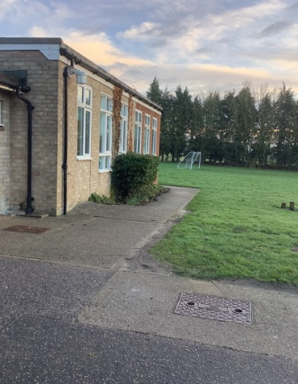  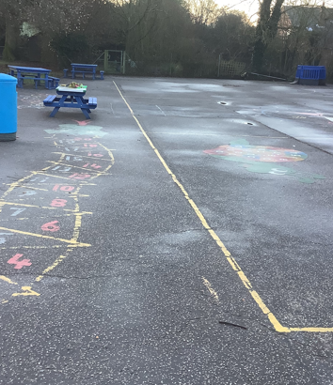 |  | This is where we line up in the morning, ready to start our day! Our teachers come out to meet us, share any important messages, and make sure we’re all set for the day ahead. Then, we follow the path around the corner and head into class, excited for the fun and learning to begin!
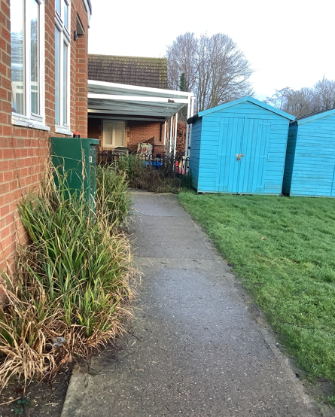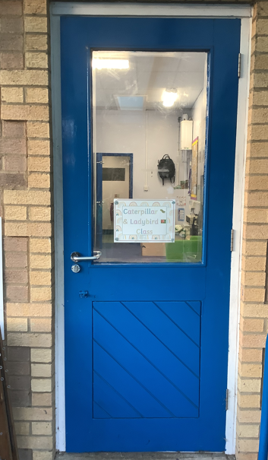 |  | This is our special outside door, where we come in each morning to start our day and head out at the end of the day with big smiles! It’s the doorway to all the fun and learning that happens in our classroom!
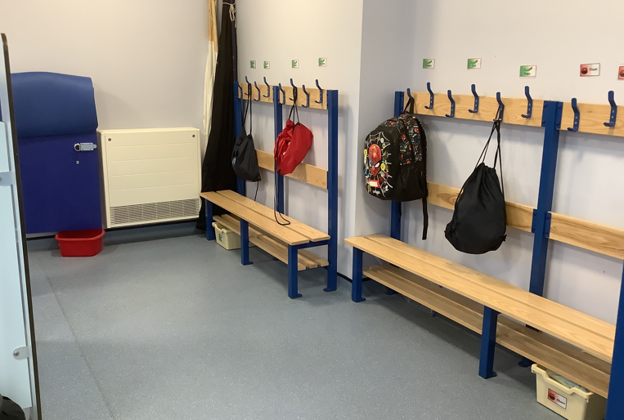 |  | When we arrive in our classroom, the first thing we do is hang up our coats in our neat cloakroom area, ready to start our day with everything in its place!
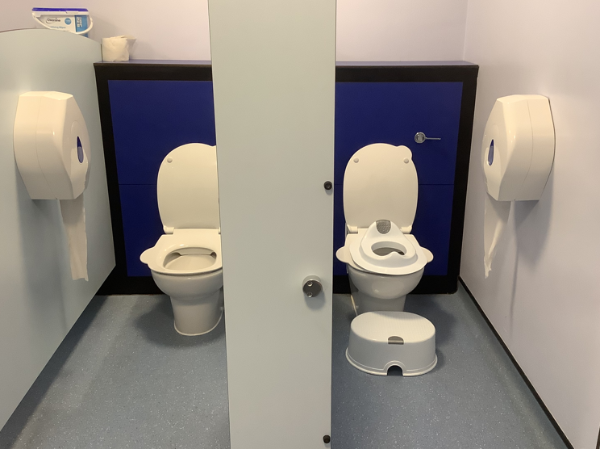 |  | Our toilets are also located in this area, making it easy for us to take a quick break whenever we need to!
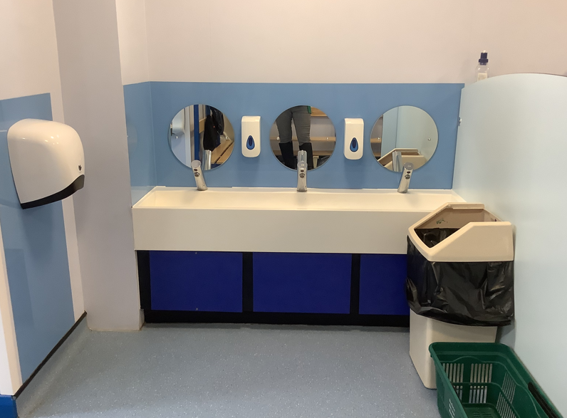 |  | This is where we wash our hands, making sure we’re all clean and ready for the next fun activity!
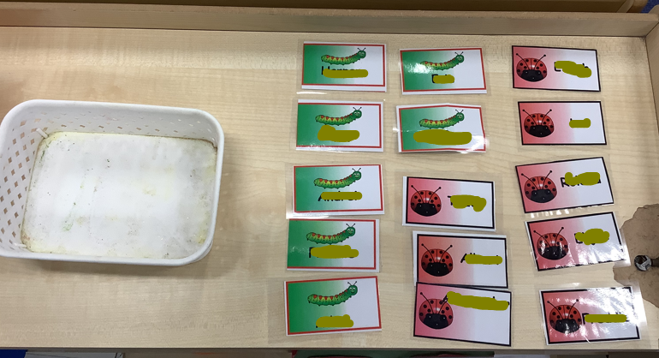 |  | Next, we find our names, place them in the basket, and then head to the carpet for registration. Don’t worry—if you’re still learning to recognise your name, an adult will be there to help you!
In the mornings, we gather together on our cosy carpet areas for exciting learning sessions full of fun and discovery! It’s a special time where we explore new ideas, play, and get ready for the day ahead.
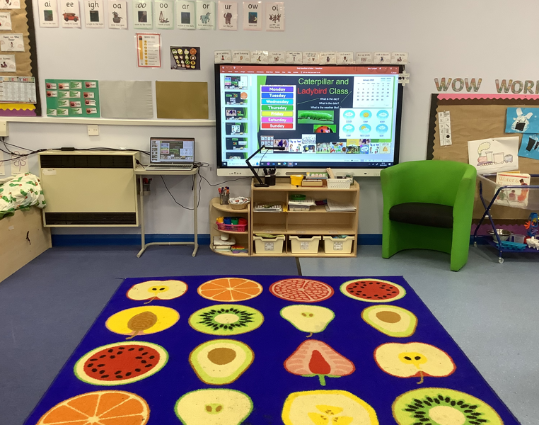 |  | 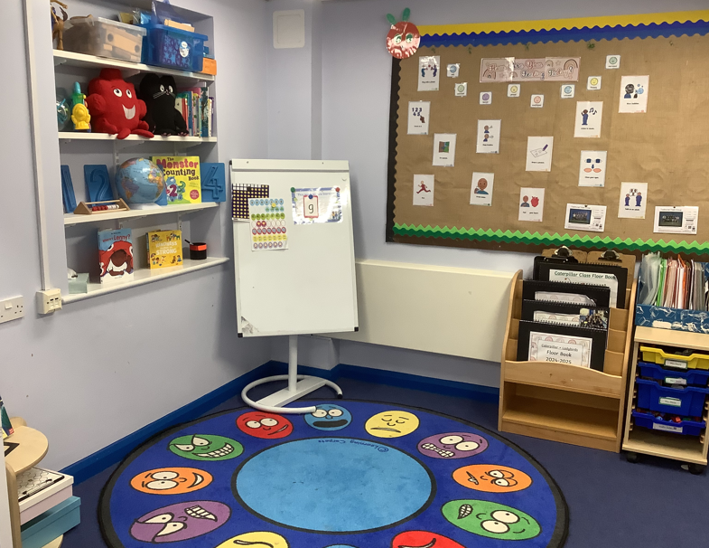
Throughout the day, we have plenty of chances to learn through play, both inside our bright classroom and out in our amazing outdoor spaces. It’s all about having fun while discovering new things, making friends, and using our imaginations!
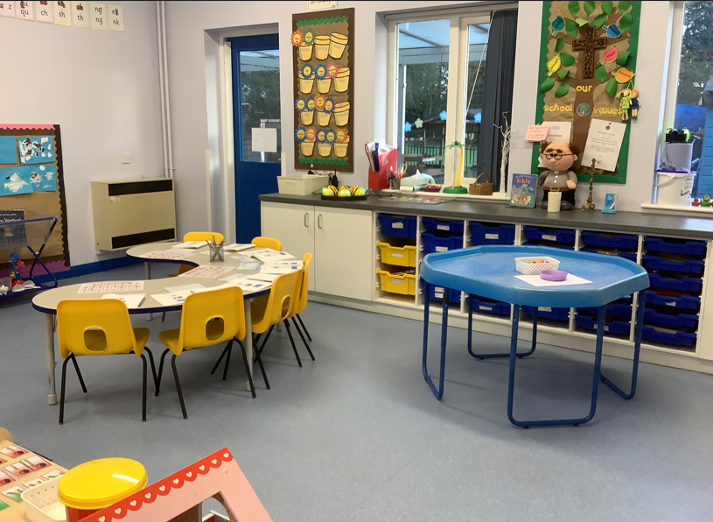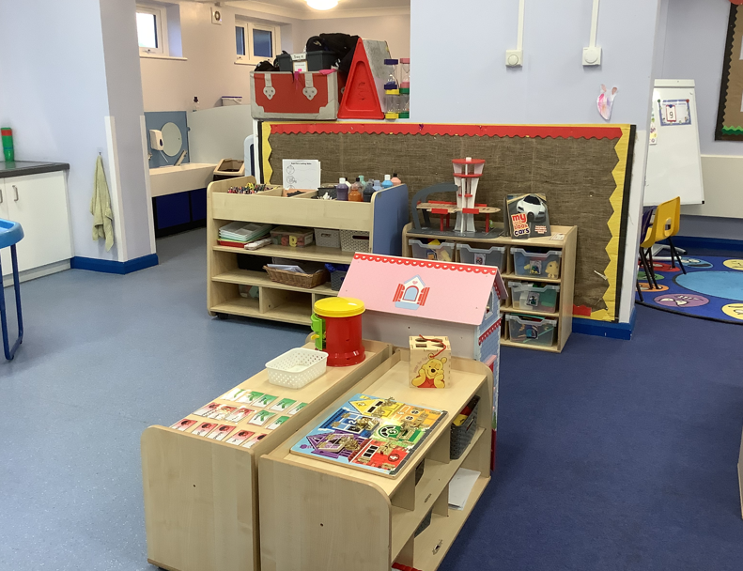
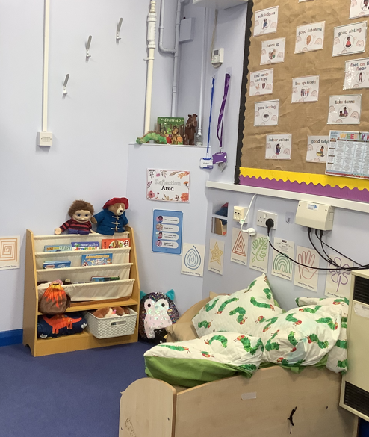 | 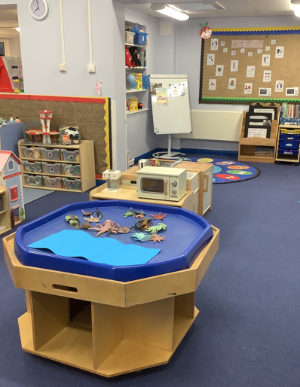 |  | 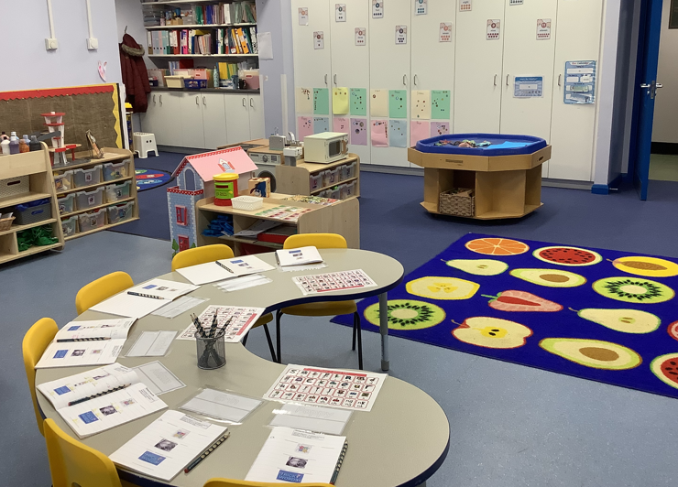
Here’s a sneak peek at more photos of our wonderful indoor and outdoor learning spaces, where every day is an adventure in discovery and fun!
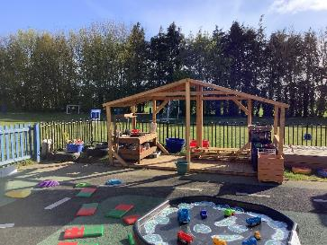 | 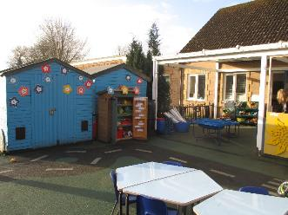 |  | 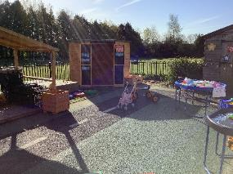
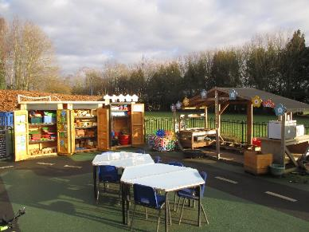 | 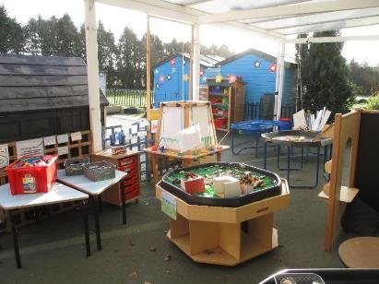 |  | 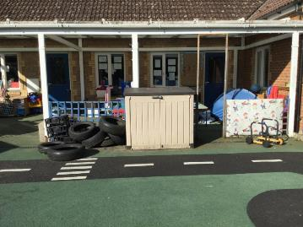
This is the hall! We come here to enjoy our lunch, take part in collective worship, and sometimes for fun PE sessions too! It’s a big, bright space where we do lots of exciting things together.

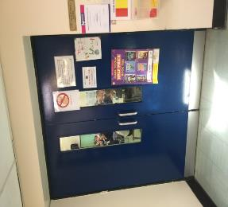
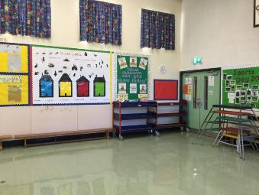

What do I need to take to school with me?
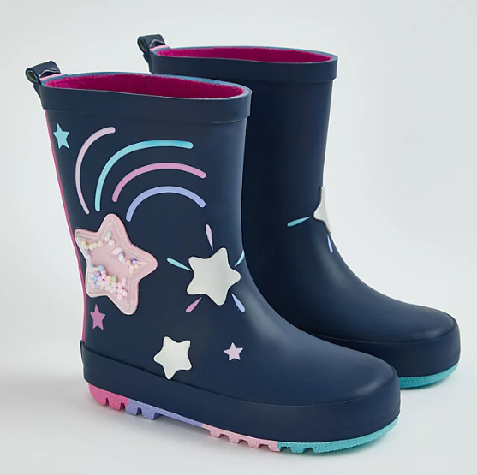  Wellington Boots – that stay in school. |   NAME all items  Water Bottle
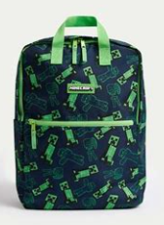  Bag to keep my items. | 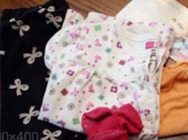  Spare clothes
  Coat – (waterproof in summer – we can never tell what the weather is like in the UK)! | 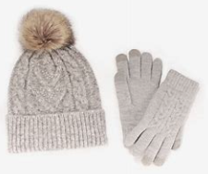  Hat and gloves in the winter months
  Sun cream and sun hat in the sumer months. | 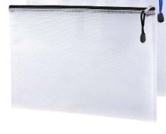  Your zip packet with your reading books – These will be provided when you start school – but must come to school everyday.
What do I need to wear at school?
Name all items as they all look the same and can easily get lost.
Pre-school Children
 |  | 
Plain red sweatshirt/cardigan | Red or white polo shirt or T-shirt.
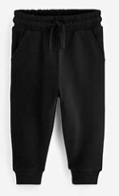 | 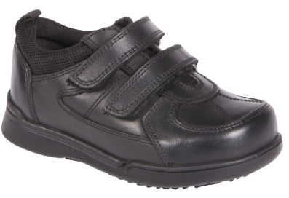  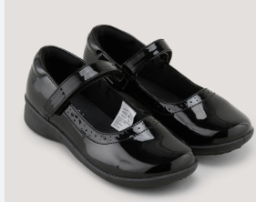
Black jogging bottoms | Black shoes or trainers.
What do I need to wear at school?
Name all items as they all look the same and can easily get lost.
Reception Children
 |  | 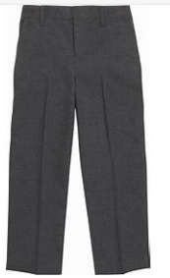
Navy Blue sweatshirt/cardigan | White polo shirt | Grey school trousers/shorts (summer)
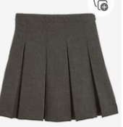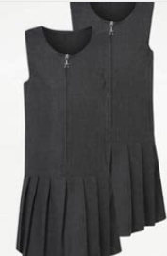  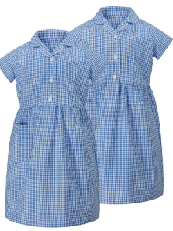 | 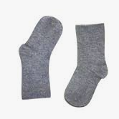    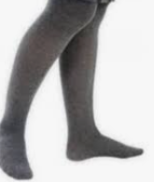
Grey skirt or dress Blue checked dress (summer) | Grey or white socks/tights | Black shoes
PE Kit – Preschool + Reception Children
We have a fun PE session once a week, so make sure to bring your PE kit to school, ready to get moving and have a great time!
 | 
T-shirt in house colour  When your child starts school, the office will inform you of the team or class your child has been assigned to | PE shorts
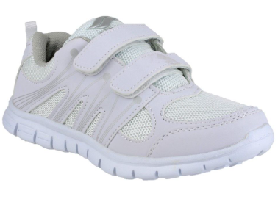  Trainers (any colour/style different to school shoes) | Indoor shoes should be different to those worn outside or children should go be in bare feet – plimsols can be worn but not essential.  During winter months and cold weather tracksuits can also be worn.
Curriculum
Our EYFS curriculum follows a two-year rolling programme of topics, designed to provide exciting and engaging learning opportunities that are tailored to each child’s age and developmental stage. Each morning, children experience a well-rounded session that includes phonics or phonological awareness, a maths talk or session, English activities, and a focus on developing a love of reading. We also enjoy nursery rhymes and songs, and there’s plenty of time for children to explore and learn through play in our carefully designed learning environments. In the afternoon, we have one focused input session, which could be music, PE, RSHE (Relationships, Sex and Health Education), RE (Religious Education), Understanding the World, or Expressive Arts. Throughout the day, we spend time within the provision learning to make friends, develop social skills, and understand how to get along with others, which is at the heart of the Characteristics of Effective Learning. Every activity is designed to nurture curiosity, creativity, and a love for learning!
An example of our timetable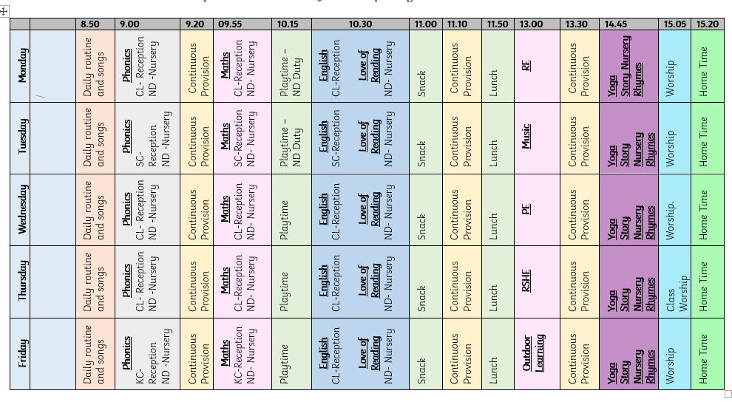
Staying Connected
How we keep you informed in the EYFS.
Our Half-Termly Newsletter keeps you informed about your child’s progress, upcoming events, and all the exciting learning happening in the classroom!
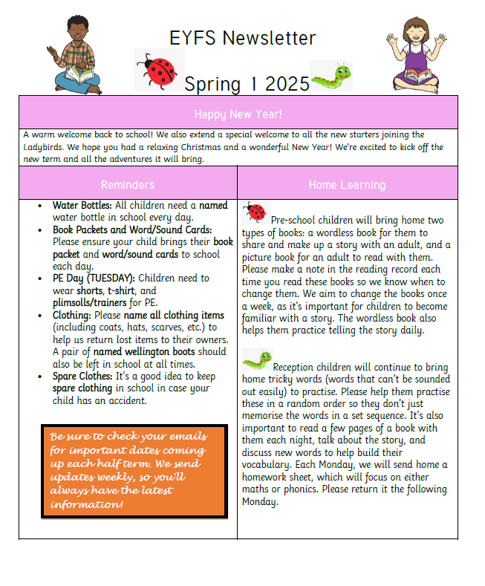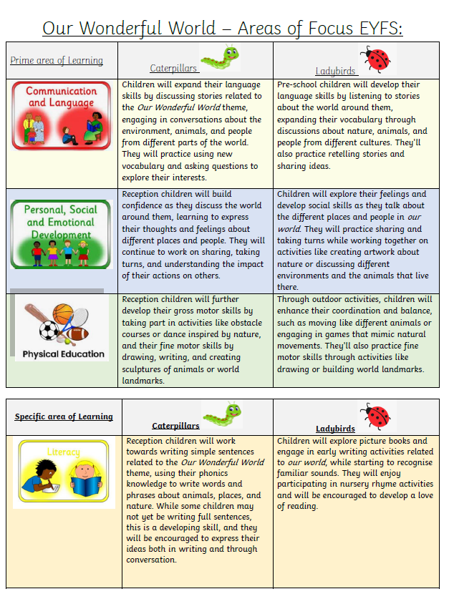
Through our online learning platform, Evidence Me, we record detailed observations of your child’s learning journey, which can be easily viewed at home. This platform also allows you to add your own observations from home, helping us to build a complete picture of your child’s progress and development both in the classroom and at home.

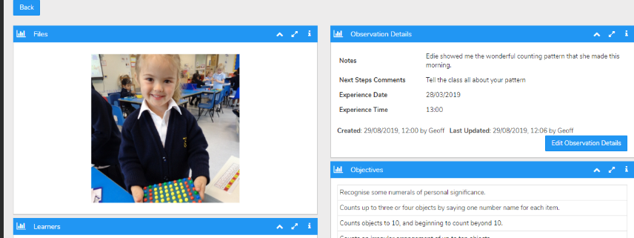
Parents Evenings
We hold two parents' evenings each year, one in the autumn term and another in the spring, providing an opportunity to discuss your child's progress and development. In the summer term, we provide a detailed school report, summarising your child’s achievements and growth throughout the year.
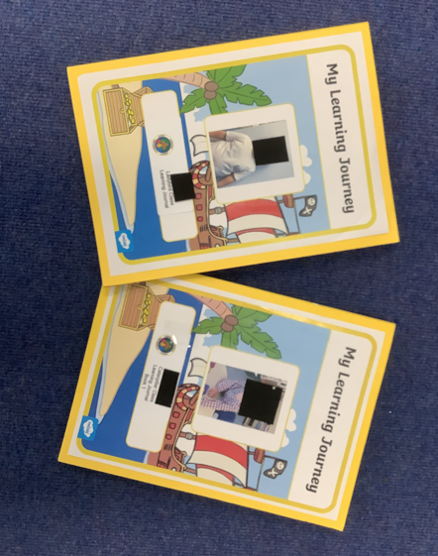
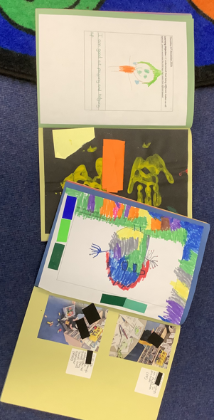
Parent Events
Once a term, we host special parent events where you can join your child in the learning environment and participate in a fun, hands-on activity together. These events give you a chance to experience first-hand the exciting learning happening in the classroom and strengthen the connection between home and school.

Together, with open hearts and hands, we look forward to nurturing your child’s growth with kindness, respect, responsibility, hope, and strength. Just as Matthew 7:7 encourages us to ‘ask, seek, knock,’ we are here to support, guide, and partner with you in every step of your child’s journey.

Contact Details
Address: Pound Hill, Saham Toney
Thetford
Norfolk IP25 7HP
Telephone: 01953 881601
E-mail: office@parkers.dneat.org

