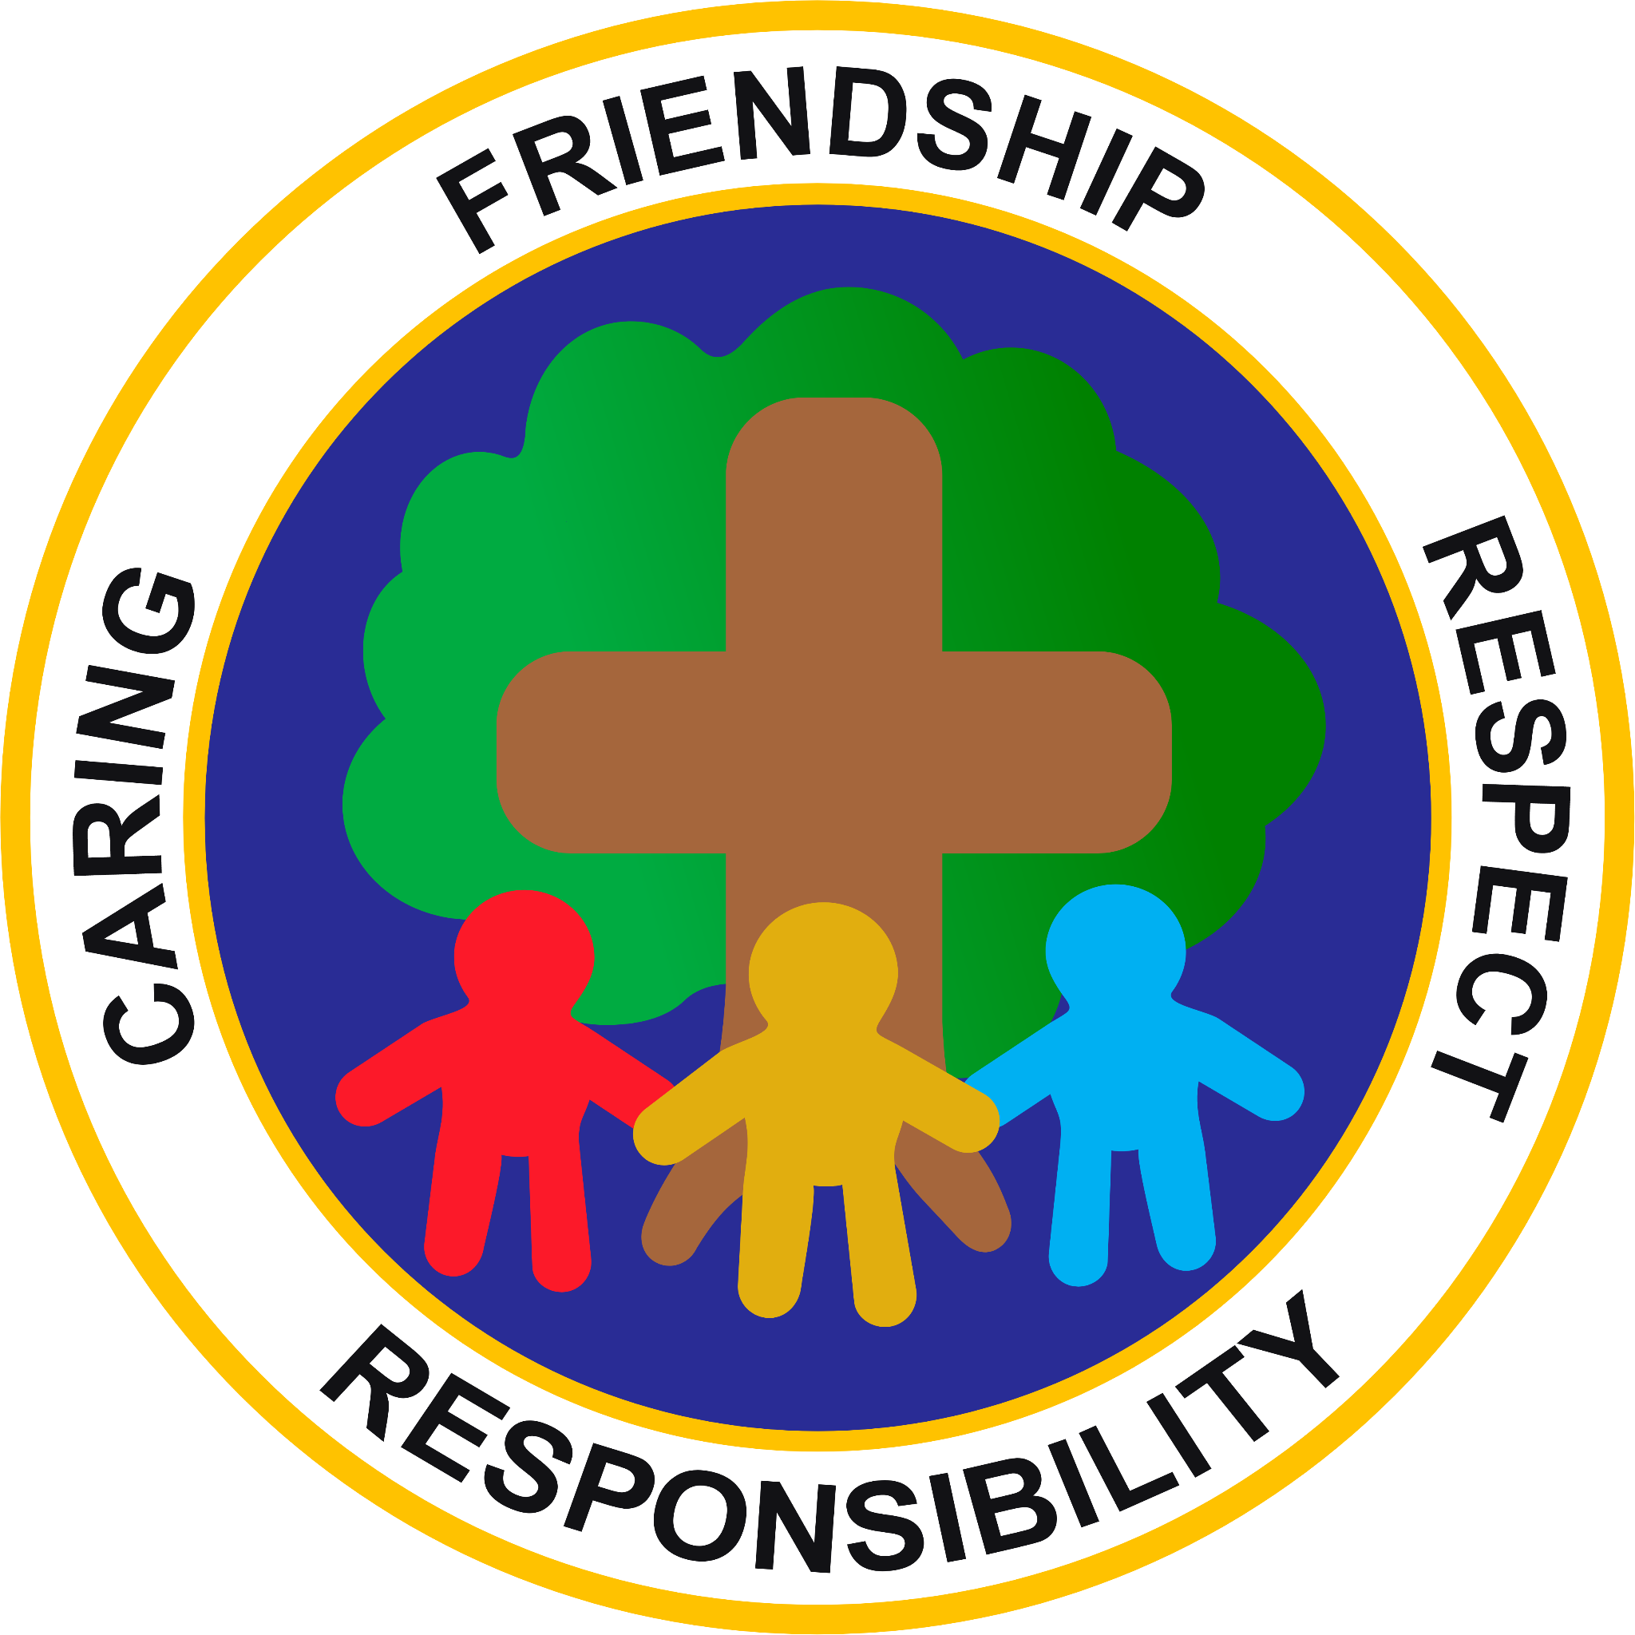

The Dove Federation
(Parker’s and Caston C of E Primary Academies)

Spirituality at The Dove Federation
Ask, Seek, Knock

“Ask and it will be given to you. Seek and you shall find. Knock and the door will be opened to you.”
Matthew 7:7
What is spirituality?

We define spirituality as an ongoing, reflective journey. It is something that teaches us about questioning, understanding and relationships: relationships with ourselves, others, the world and beyond. Christian values are firmly rooted in our approached. Our Christian values are respect, kindness, responsibility, hope, strength and unity.
Spirituality enables our children to be happy; flourish and succeed and live life in all of its fullness.

How do we teach spirituality?

Our federation aims to support children in making sense of themselves and the world around them. We aim to help pupils to observe their own responses to different experiences. We believe that experiences both in and out of school are an important part of the spiritual development of all pupils. Our children are given opportunities to question and reflect throughout the whole school curriculum, during collective worship and throughout the school day. Visitors and trips provide opportunities for pupils to reflect on the past, present and future. We encourage staff to organise a variety of trips and visitors during the school year. Reflection spaces are available throughout the school. At the end of each lesson and collective worship pupils are given time for reflection. Throughout the school day there are regular times for prayer and reflection including the saying of grace before lunch and prayer during collective worship.

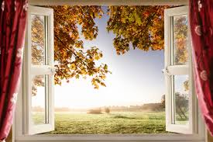 | Learning is like looking through a window to see new horizons - looking at the world in new ways. | Windows are for looking out onto the world and becoming aware of its wonders, both the ‘wows’ and ‘ows’; things that are ‘awe-full’ and make us wonder and be grateful and things that are ‘awful’ and make us wonder and ask questions. The whole curriculum and life itself are full of opportunities to recognise this sensitively.
 | Reflection is like looking in a mirror and having time to reflect on the learning and ourselves. | Mirrors are for looking into and reflecting, alone and together, to see things more clearly, for thinking and asking important questions learning from our own and each other’s responses. In schools we must allow time for this for individual and group reflection and sharing of perspectives. Some subjects and times allow for this specifically, such as religious education and collective worship but in all subjects, there will be opportunities, unexpected or planned, when things just ‘crop up’. Handled sensitively, it is possible to make the most of all these times, if there is ongoing deliberate and corporate staff and pupil  support.
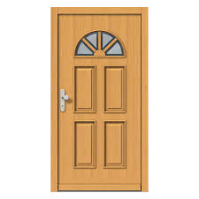 | Responding is like going through a door considering how the learning will have an impact on yourself or your behaviour. It is about understanding how others feel. | Doors are for looking through in order to then act or express this in some way in response; for moving on, making choices, and doing something creative, active and purposeful in response. This can simply be done through a change in attitude or behaviour or thinking. It can also be expressed powerfully through music or art or drama or dance and through some form of social action or specific acts of giving.

Opportunities for spirituality

Opportunities for spirituality development come when:
- we are given space to stop, look, listen, think and reflect
- we feel safe to share opinions and think differently from others
- children and adults use their imagination
- we are given time to be listened to
- we have the space to explore, think and discuss
- there are opportunities that encourage wonder and surprise
- there is the time to ‘just be’ and to experience peace and stillness

Spirituality across our curriculum

Subject | Opportunities
PE | - Through P.E, we enable spiritual development by allowing our children the freedom to move and express themselves. During dance lessons pupils listen to music and are provided with opportunities to express their own views on the music and dance and think about how it makes them feel. We build wonder in their achievements as they learn a new skill and share this with others.
Computing | - Children are given a variety of exciting opportunities to express themselves through coding & programming, creating media and collecting data. They develop ideas and present these in a range of formats using information technology. Children are encouraged to be responsible and safe while using the internet, being mindful of themselves and others. Children are given opportunities to express their own views when using technology.
Design and Technology | - We inspire creativity and imagination, children can design, make and evaluate products that solve relevant and real problems within a variety of contexts, looking not only at their own needs, wants and values, but also the considerations of others. We celebrate personal creativity by exploring extraordinary design, inspiring awe and wonder through beauty, functionality and the magnitude of some designs.
Music | - In music, children share a unique part of themselves by using their voices expressively and listen intently to others’ voices. They experience the sense of joy and wonder of performing together, being both responsible for their own role and part of something bigger. Children are given the opportunity to reflect on the music that they listen to and think about how pieces of music allow them to feel.
Art and Design | - Through Art and Design at pupils are given the opportunity to appreciate, reflect and respond to a wealth of artists and their work. Drawing upon their social, historical, geographical and religious backgrounds. Children are given the opportunity to reflect on their own and others work and are provided with opportunities to feel proud of their achievements.
PSHE/RSHE | - Through RSHE, we encompass spirituality by developing an awareness of, and responding to others’ needs and wants. We recognise  people’s worth and values. We have a strong sense of community which inspires children to grow into confident and resilient individuals. Pupils are given the opportunities to think about themselves and those around them. Units of work include families, relationships, goals and dreams.
RE | - By experiencing wonder and joy through learning about and from stories, celebrations, rituals and different expressions of religion and worldviews. By asking and responding to questions of meaning and purpose.  - By considering questions about God and evaluating truth claims.  - By exploring spiritual practices such as worship and prayer, and considering the impact of these on believers as well as any relevance to their own life.
Geography | - By creating a sense of awe and wonder by exploring the natural world. Creating curiosity amongst children and enabling them to ask questions about the world around them. Discovering their place in the world and comparing this to other people’s experiences and other places. Understanding how the human and physical world can help children identify themselves.
History | - By considering how things would be different if the course of events had been different; for example what difference would it have made if the Normans had not been successful in 1066?
MFL | - By exploring the beauty of languages from around the world.  - By exploring the way language is constructed.
Science | - Throughout our Science curriculum, we provide many opportunities for pupils to learn about nature, explore the role they play in protecting our world and how they can contribute to their wider environment. Through the skills children learn as scientists, children are encouraged to ask ‘big questions’ about the world around us, take risks, demonstrate curiosity and open mindfulness. Staff model openness to the fact that not all answers can be provided by Science.
Literacy | - We provide opportunities for pupils to respond to different text types by taking inspiration from other authors. We learn to appreciate the beauty of language and how we can create text through using words and our imaginations.  - Through well-chosen texts pupils are given the opportunity to value each other’s reactions, ideas and opinions and learn to empathise with characters' feelings and actions - interpreting their thoughts and making connections to our own lives, values and the wider world around us.
Maths | - Children are introduced to the wonder of numbers, including numerical patterns, order, shape and space. Investigations and problem solving provide moments of awe and wonder, where children are encouraged to deepen their understanding. There are opportunities to make connections between numeracy skills and real life throughout our curriculum.

