Friends of Parker’s Primary School 2023-24 Update

Thanks for supporting the Friends of Parker's Primary School over this school year!



All events run by the Friends are organised and staffed by volunteers. They are put on to add to the children's enjoyment of school, increase the sense of community between parents and school, and raise money to support the school with additional experiences and equipment.

Over this school year, the Friends have raised a grand total of £3,390! This breaks down to £2,027 in general funds and £1,363 raised for a new outdoor learning area.

The Friends spent £2,066 over the same period, supporting school trips, activities, new equipment, and gifts for the children. See the breakdown of spending below:

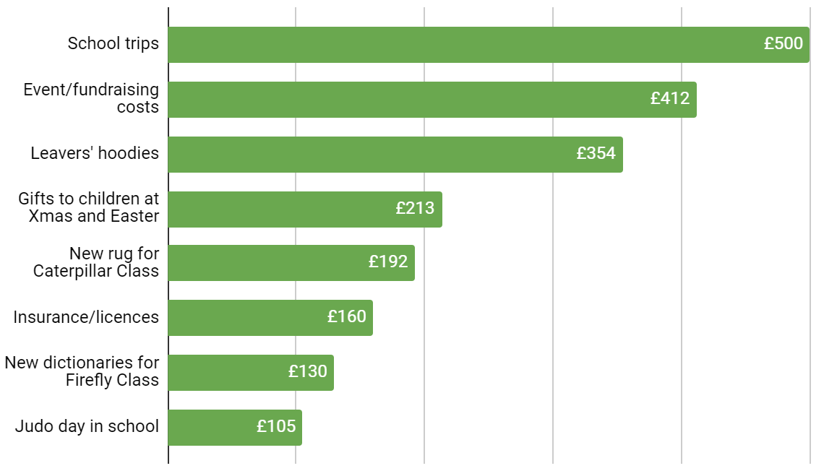

They are excited to start developing the outdoor learning area over the coming year – if this is something you might be able to help with in a practical or a fundraising sense, get in touch!

The Friends’ AGM will take place early next school year so watch out for the date if you'd like to learn more or get involved. They are always looking for new volunteers to help with events or contribute time and skills to fundraising, so do reach out if this could be you.

The current Friends of Parker’s trustees are Sarah Pattison (Georgia/Eliza/Hugo's mum), Nicola Marison (Jasmine/Skye's mum) and Hayley Gray (Alex's mum) – speak to them in the playground to find out more or email the Friends at friendsofparkers@gmail.com.
Friends of Parker's Primary School (FOPPS) is a registered charity with the Charity Commission for England and Wales (charity no. 1188682).

