Dove Federation
Vision Statement for Mathematics

At the Dove Federation, guided by Christian values, we strive to provide a nurturing and inclusive environment where every child is valued and challenged to reach their full potential. Inspired by the words of Jesus in Matthew 7:7 – ‘Ask and it shall be given unto you, seek and you shall find, knock and the door shall be opened’ – we encourage our children to seek knowledge, wisdom, and understanding through prayer, reflection and exploration.
We aim to develop confident, compassionate and responsible individuals who embody respect, kindness, responsibility, hope, strength and unity. We are committed to promoting the wellbeing of our pupils and staff, and to creating a community where everyone feels supported and valued. Through our curriculum, we encourage our children to knock on doors to exciting opportunities in our world, and to develop the skills and knowledge they need to make a positive impact in their communities and beyond.
We want our children to have high aspirations and believe that they can achieve great things if they work hard and persevere. We are committed to enhancing the lives of our pupils through a range of experiences that broaden their horizons, challenging them to think critically, and to inspire them to become lifelong learners.
We provide a broad and balanced, knowledge rich curriculum which is stimulating and challenging, catering for all. It aims to give children secure subject knowledge and skills, an understanding of language and subject specific vocabulary, an ability to reflect and evaluate their work as well as promoting creativity, independence and encourage lifelong enjoyment of the subject. Our curriculum provides opportunities for children to explore and engage with ideas and experiences outside their everyday life experience.
Mathematics is taught in all years groups on a daily basis. Mental maths, times tables and number bonds are taught on a daily basis.
Our maths curriculum aims to develop pupils reasoning, fluency and problem solving skills. In line with the National Curriculum we want pupils to become fluent in the fundamentals of mathematics, including through varied and frequent practice with increasingly complex problems over time, so that our pupils develop conceptual understanding and the ability to recall and apply knowledge rapidly and accurately. We also want pupils to be able to reason mathematically by following a line of enquiry, conjecturing relationships and generalisations, and developing an argument, justification or proof using mathematical language. Through their learning we aim for pupils to be able to solve problems by applying their mathematics to a variety of routine and non-routine problems with increasing sophistication, including breaking down problems into a series of simpler steps and persevering in seeking solutions.
A key focus of our programmes of study is retrieval practice.
We place emphasis on language acquisition across our curriculum areas. Our children learn about the language of Mathematics, developing their understanding of its own vocabulary and the meaning of specific words. We want children to have the appropriate vocabulary to express their knowledge and understanding of Mathematics.

EYFS Year 1 and 2
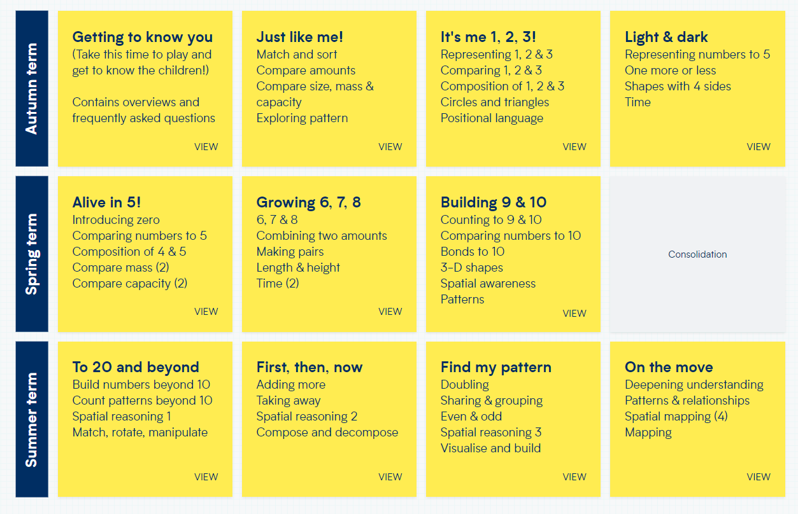
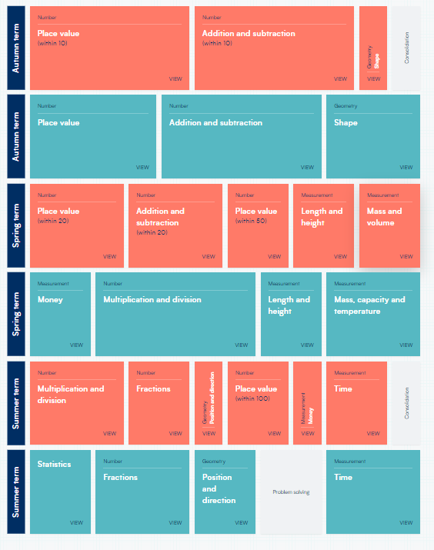

Year 3/4 Year 5/6
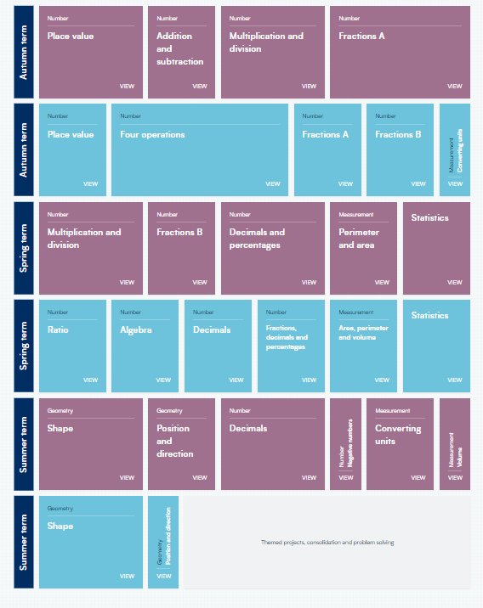
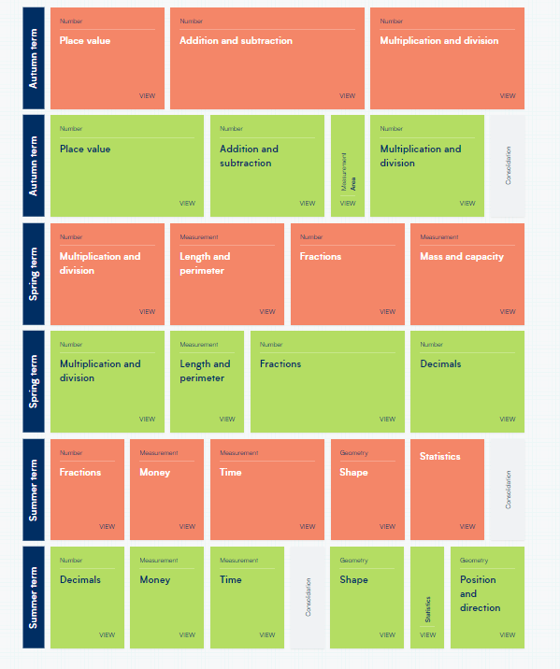

Key objectives that would be covered in each unit of work

EYFS


